**Final Report**

**for**

**Provision of Legal Consultancy Services to**

**Produce Data Protection Legislation for**

**the Government of Malawi**

REF NO.: MW-PPPC-62396-CS-QCBS

Project No: P16053

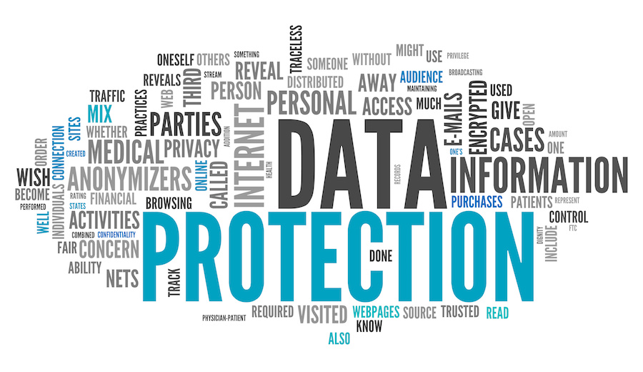

Submitted by:

Macmillan Keck

Attorneys & Solicitors

**9 September 2022**

Contents

1 Introduction 1

2 Phase 1 – New Legislation 1

2.A Kick-off and Inception Report 1

2.B Sensitization workshops and capacity building 1

2.C Legislation Policy Report 1

2.D Preparation of new legislation 1

2.E Validation and dissemination workshops 1

2.F Finalisation of the bills 2

3 Phase 2 – Secondary Legislation 2

3.A Kick-off and Inception Report 2

3.B Drafting secondary legislation 2

3.C Stakeholder consultations and Stakeholder Consultation Report 2

3.D Finalisation of the secondary legislation and Final Report 2

# Introduction

In this Final Report, we set out the work completed within the framework of this assignment. Section 2 lists our team members and Sections 3 and 4 summarize the steps taken under Phase 1 and Phase 2 of the assignment, respectively.

# Phase 1 – New Legislation

## Kick-off and Inception Report

The project kicked off after contract signing in June 2019. First, we held a videoconference to discuss the project with the MICT, the PPPC and other relevant Task Force members to address any changes or updates since the issuance of the TOR. During this discussion, we also identified the relevant legal instruments needed for our legal review.

At the conclusion of this initial preparation stage, we delivered a draft Inception Report on 5 August 2019, followed by a revised draft on 16 September 2019. After the delivery of the Inception Report, we started our desk review, which included an assessment of the existing data protection framework in Malawi and a best practices review.

## Sensitization workshops and capacity building

We visited Malawi in January 2020 to conduct Task Force Training and Sensitization workshops. We had a chance to interact with representatives of the public sector and the private sector in two cities in Malawi: in Blantyre and in Salima. These workshops consisted of presentations to stakeholders on best practices and an assessment of Malawi laws.

Rory Macmillan (Team Leader and Legal Expert), Jason Blechman (Supporting Legal Expert) and Steve Matenje (Legal Drafting Expert) led these workshops. We also had face-to-face meetings with the MICT and other Task Force members to discuss progress and next steps in the project and provided capacity building.

## Legislation Policy Report

We delivered a comprehensive Legislation Policy Report on 3 March 2020. We received feedback received from MACRA and PPPC on this report, which we used in shaping the legislation in the upcoming stages of the assignment.

## Preparation of new legislation

In light of the legal review and sensitization workshops, we drafted the data protection bill and a set of amendments to various other laws. We delivered a set of first draft legislation to the MICT and the Task Force on 8 September 2020, which included:

* Malawi Data Protection Bill
* Electronic Transaction and Cyber Security (Amendment) Bill
* Access to Information (Amendment) Bill

## Validation and dissemination workshops

After the bills were accepted by the Task Force, we organised validation workshops, which were held remotely due to travel restrictions during the COVID-19 pandemic. The Task Force sent invitations to stakeholders to join the workshop held on 2 March 2021 and to comment on the Draft Data Protection Bill and to submit written comments on the Draft Bill by 26 February 2021. We received written feedback from various actors including the Government, the Task Force, and several private sector organisations during this window.

## Finalisation of the bills

We prepared and delivered post-consultation drafts of the Electronic Transaction and Cyber Security (Amendment) Bill and the Access to Information (Amendment) Bill on 28 April 2021, followed by the post-consultation Data Protection Bill on 30 April 2021. Based on the feedback from the Task Force, we prepared and delivered the final draft of the Data Protection Bill on 30 June 2021.

# Phase 2 – Secondary Legislation

## Kick-off and Inception Report

After successful completion of Phase 1, which resulted in delivery of a draft Data Protection Bill and draft amendments to the Access to Information Act and Electronic Transactions and Cyber Security Act, we received instructions from the Task Force that Phase 2 has commenced.

We kicked off Phase 2 by a conference call confirming our understanding of the scope of work for Phase 2. Following this conference call, we prepared and delivered the Phase 2 Inception Report on 10 November 2021.

## Drafting secondary legislation

During this phase of the assignment, we prepared five pieces of secondary legislation, which will be adopted based on the powers that the Act will confer on the Authority once it enters into force. These rules and guidelines are as follows:

* Guideline and Checklist on Compliance
* Rules on Registration and Annual Fees
* Rules on Reasonable Measures for Engaging a Data Processor
* Guidelines on Data Breach Notifications
* Rules on Complaints and Investigations

We delivered a first draft of the Rules on Registration and Annual Fees and the Rules on Reasonable Measures for Engaging a Data Processor on 26 April 2022, followed by the Rules on Procedures for Handling Complaints and Conducting Investigations and Guideline on Data Protection Notifications on 1 May 2022. We delivered the Guideline and Checklist on Compliance on 9 June 2022. We circulated a revised set of drafts on 23 June 2022, which incorporated feedback from local counsel Steve Matenje and fixed problems with formatting and cross-references.

## Stakeholder consultations and Stakeholder Consultation Report

We presented the five pieces of secondary legislation via Zoom during the stakeholder consultations held on July 26-27, 2022. A conference room was set up at MACRA’s premises with videoconferencing capabilities. The stakeholders were given the option to join remotely or physically. Two 3-hour sessions were scheduled on two consecutive days.

The stakeholders had the opportunity to submit written feedback during the 14-day window that followed the consultations. We compiled the feedback received during and after the stakeholder consultations in the Stakeholder Consultation Report, which we delivered on 5 September 2022.

## Finalisation of the secondary legislation and Final Report

Based on feedback and input from stakeholders during the stakeholder consultations, we shared a revised set of rules and guidelines on 5 September 2022, which were approved by the Task Force on 15 September 2022, along with this Final Report. This Final Report marks the conclusion of Phases 1 and 2 of this assignment.